CO-2 ASSESSEMENT -2
Submitted By
Name: ____A.V. Ameya___________________
Register Number: ______192472036_________________
Department: B. Tech Computer Science and Engineering (Artificial Intelligence)
Year: Third Year
Course: Generative AI

CASE STUDY – 8
Develop an Appropriate Solution for the Given Generative AI/LLM Scenario
Topic: Vector Databases (FAISS / ChromaDB)

Abstract
Generative Artificial Intelligence (Generative AI) has transformed the way intelligent systems generate and process information. Large Language Models (LLMs) such as GPT and BERT can understand natural language and produce human-like responses. However, these models may provide outdated or inaccurate information when they rely only on their pre-trained knowledge. To address this challenge, Vector Databases such as FAISS and ChromaDB are used to store and retrieve information based on semantic similarity rather than simple keyword matching.
This case study presents a solution for integrating LLMs with vector databases to improve information retrieval and response generation. It includes scenario analysis, suitable model selection, implementation approach, system architecture, and expected outcomes. The study also explains how embeddings and semantic search enable fast and accurate retrieval of relevant documents, making AI systems more reliable and efficient.
The proposed solution demonstrates that combining LLMs with FAISS or ChromaDB enhances the performance of AI-powered applications such as chatbots, document search systems, question-answering platforms, and enterprise knowledge management. Finally, the report discusses the advantages, limitations, and future scope of vector databases in modern Generative AI applications.

PART 1 : Introduction
1.1 Introduction
Generative Artificial Intelligence (Generative AI) is a branch of Artificial Intelligence that creates new content such as text, images, audio, videos, and code based on user input. It uses advanced machine learning models to understand patterns in large datasets and generate human-like responses. Today, Generative AI is widely used in virtual assistants, chatbots, content creation, healthcare, education, and software development.
Large Language Models (LLMs) such as GPT and BERT are powerful AI models trained on massive amounts of text data. These models understand natural language and provide intelligent responses to user queries. However, LLMs cannot always access updated or organization-specific information because their knowledge is limited to their training data.
To solve this problem, Vector Databases such as FAISS and ChromaDB are used. A vector database stores text in the form of numerical vectors (embeddings). When a user asks a question, the query is converted into an embedding and compared with stored vectors to find the most relevant information. This process is called semantic search, which improves the accuracy and relevance of AI-generated responses.
1.2 Objectives
- To understand the role of Vector Databases in Generative AI.
- To study the working of FAISS and ChromaDB.
- To improve information retrieval using semantic search.
- To integrate LLMs with vector databases for better response generation.
- To analyze the advantages and limitations of vector databases in AI applications.

1.3 Basic Working of LLM with Vector Database
User Query
Final AI Response

PART – 2 (Page 2): Introduction
1. Introduction
Generative Artificial Intelligence (Generative AI) is a branch of Artificial Intelligence that creates new content such as text, images, audio, videos, and code based on user input. It uses advanced machine learning models to understand patterns in large datasets and generate human-like responses. Today, Generative AI is widely used in virtual assistants, chatbots, content creation, healthcare, education, and software development.
Large Language Models (LLMs) such as GPT and BERT are powerful AI models trained on massive amounts of text data. These models understand natural language and provide intelligent responses to user queries. However, LLMs cannot always access updated or organization-specific information because their knowledge is limited to their training data.
To solve this problem, Vector Databases such as FAISS and ChromaDB are used. A vector database stores text in the form of numerical vectors (embeddings). When a user asks a question, the query is converted into an embedding and compared with stored vectors to find the most relevant information. This process is called semantic search, which improves the accuracy and relevance of AI-generated responses.
Integrating LLMs with vector databases forms the basis of Retrieval-Augmented Generation (RAG), where the LLM retrieves relevant information before generating the final answer. This approach provides faster, more accurate, and context-aware responses.

2. Objectives
- To understand the role of Vector Databases in Generative AI.
- To study the working of FAISS and ChromaDB.
- To improve information retrieval using semantic search.
- To integrate LLMs with vector databases for better response generation.
- To analyze the advantages and limitations of vector databases in AI applications.

3. Basic Working of LLM with Vector Database
User Query
│
▼
Convert Query to Embedding
│
▼
Vector Database
(FAISS / ChromaDB)
│
Similarity Search (Top Matches)
│
▼
Relevant Documents
│
▼
Large Language Model
(GPT / BERT / LLM)
│
▼
Final AI Response
Figure 2.1: Basic workflow of an LLM integrated with a Vector Database.

4. Key Components
Component | Description
User Query | Question asked by the user.
Embedding Model | Converts text into numerical vectors.
Vector Database | Stores and retrieves vector embeddings.
Similarity Search | Finds the most relevant information.
LLM | Generates human-like answers using retrieved data.
Final Response | Accurate and context-aware output presented to the user.

5. Importance of Vector Databases
- Stores high-dimensional embeddings efficiently.
- Enables semantic search instead of keyword matching.
- Improves LLM response accuracy.
- Supports Retrieval-Augmented Generation (RAG).
- Handles large-scale AI applications with fast retrieval.
- Reduces hallucinations by providing relevant context.

Large Language Model (GPT / BERT / LLM)
Relevant Documents
Similarity Search (Top Matches)
Convert Query to Embedding

Vector Database (FAISS / ChromaDB)

.

Key Components
Component | Description
User Query | Question asked by the user.
Embedding Model | Stores and retrieves vector embeddings.
Vector Database | Finds the most relevant information.
Similarity Search | Accurate and context-aware output presented to the user.

1.4 Importance of Vector Databases
- Stores high-dimensional embeddings efficiently.
- Enables semantic search instead of keyword matching.
- Improves LLM response accuracy.
- Supports Retrieval-Augmented Generation (RAG).
- Handles large-scale AI applications with fast retrieval.
- Reduces hallucinations by providing relevant context.

PART – 2: Background of the Study & Need for Vector Databases

2.1 Background of the Study
- Artificial Intelligence (AI) has rapidly evolved over the past decade, leading to the development of advanced technologies such as Generative Artificial Intelligence (Generative AI). Generative AI enables machines to create human-like content, including text, images, audio, videos, and programming code. Large Language Models (LLMs), such as GPT and BERT, are widely used to understand natural language and generate meaningful responses for various applications.
- Although LLMs are highly powerful, they mainly depend on the knowledge available during their training. They may not always provide updated or organization-specific information. This limitation affects the accuracy and reliability of AI-generated responses, especially in applications that require real-time or domain-specific knowledge.
- To overcome this challenge, Vector Databases have become an important component of modern AI systems. They store information as vector embeddings and retrieve data based on semantic similarity instead of exact keyword matching. Popular vector databases such as FAISS and ChromaDB help AI applications retrieve the most relevant information quickly, improving the quality of responses generated by LLMs.

2.2 Need for Vector Databases
- Traditional databases are designed to store structured information such as numbers, names, and records. They perform searches based on exact keywords or conditions. However, they are not suitable for handling unstructured data such as documents, articles, PDFs, emails, and web pages.
- Vector databases solve this problem by converting text into embeddings (numerical vectors). These embeddings capture the meaning and context of the text. When a user submits a query, the vector database compares the query embedding with stored embeddings and retrieves the most relevant information using semantic similarity.
- This approach improves the performance of AI-powered chatbots, search engines, recommendation systems, and Retrieval-Augmented Generation (RAG) applications.
2.3 Traditional Database vs Vector Database
Traditional Database | Vector base
Uses keyword-based search | Uses semantic similarity search
Stores structured data | Stores vector embeddings
Requires exact keyword matching | Understands the meaning of the query

2.4 Advantages of Using Vector Databases
- Enables semantic search instead of keyword matching.
- Provides faster retrieval of relevant information.
- Improves the accuracy of Large Language Models.
- Supports Retrieval-Augmented Generation (RAG).
- Handles large volumes of unstructured data efficiently.
- Reduces incorrect or hallucinated AI responses.
- Easily integrates with GPT, BERT, and other LLMs.
- Scales well for enterprise AI applications.

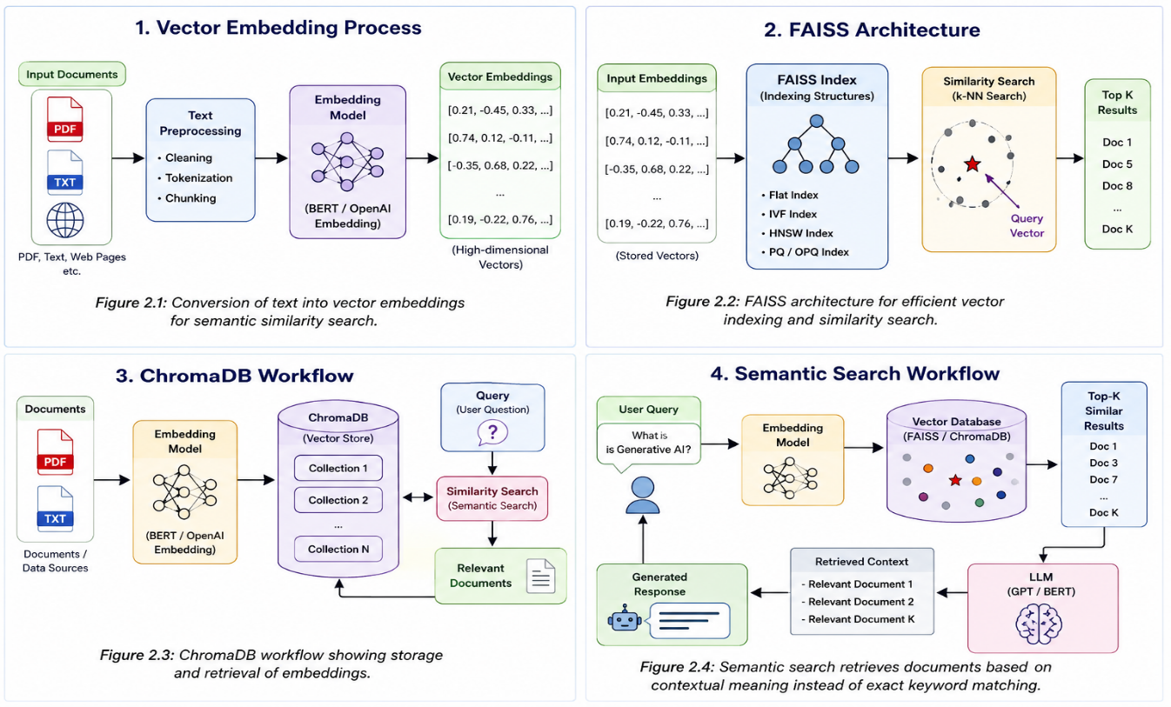

PART – 3 : Problem Statement & Scenario Analysis
3.1 Problem Statement
Large Language Models (LLMs) such as GPT and BERT have significantly improved the ability of AI systems to understand and generate human language. However, these models have a major limitation: they rely on the data used during training and cannot automatically access newly added or organization-specific information. As a result, they may generate outdated, incomplete, or inaccurate responses.
Traditional databases also face challenges when handling large collections of unstructured documents such as PDFs, reports, manuals, and research papers. They mainly depend on keyword matching, which often fails to understand the actual meaning and context of a user's query.
To solve these problems, Vector Databases such as FAISS and ChromaDB can be integrated with Large Language Models. These databases store document embeddings and retrieve the most relevant information using semantic similarity search. The retrieved information is then passed to the LLM, allowing it to generate accurate, context-aware, and reliable responses.
3.2 Scenario Analysis
Consider a company that stores thousands of technical manuals, employee policies, project documents, and customer support guides. Employees often need quick answers to their questions, but searching through thousands of documents manually is time-consuming and inefficient.
To improve document retrieval, the company develops an AI-powered chatbot integrated with FAISS or ChromaDB. Whenever an employee asks a question, the system converts the query into a vector embedding and searches the vector database to find documents with similar meanings. The retrieved information is then provided to the Large Language Model, which generates a clear and accurate response.
This approach allows employees to access the required information quickly without reading multiple documents, improving productivity and reducing search time
3.3 Existing Challenges
The organization faces several challenges while retrieving information from large document collections:
- Traditional keyword-based search often returns irrelevant results.
- Employees spend significant time searching for the correct document.
- LLMs cannot answer questions about newly added documents without external retrieval.
- Managing thousands of documents manually is difficult.
- AI-generated responses may contain incorrect or outdated information if relevant context is unavailable.
3.4 Proposed Solution
The proposed solution combines Vector Databases (FAISS/ChromaDB) with a Large Language Model to build an intelligent document retrieval system.The process begins by converting all documents into vector embeddings using an embedding model. These embeddings are stored in a vector database. When a user submits a query, it is also converted into an embedding and compared with the stored vectors. The most relevant documents are retrieved using semantic similarity search. Finally, the retrieved content is provided to the LLM, which generates an accurate and context-aware response for the user.This solution improves search accuracy, reduces response time, and enables the AI system to answer questions using the latest available information.
3.5 Benefits of the Proposed Solution
- Provides faster document retrieval.
- Understands the meaning of user queries instead of exact keywords.
- Improves the accuracy of AI-generated responses.
- Reduces hallucinations in Large Language Models.
- Supports Retrieval-Augmented Generation (RAG).
- Easily scales to handle large document collections.
- Enhances productivity by reducing manual document searches.
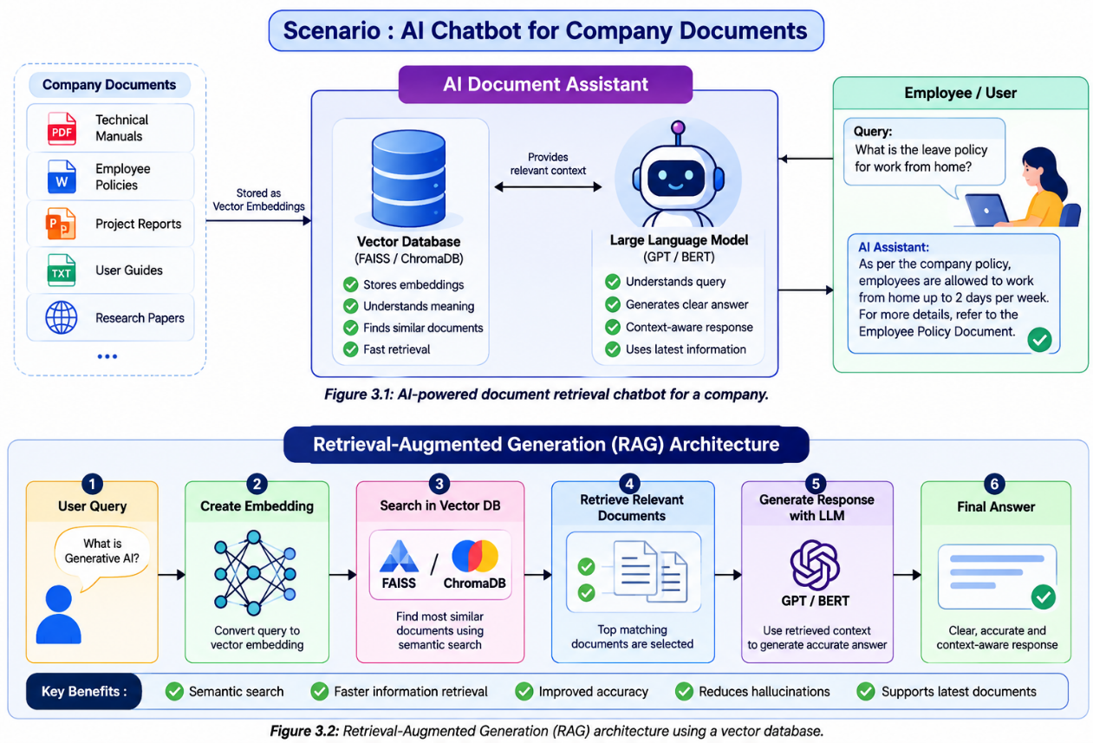

PART 4. Suitable Model Selection and Justification
Selecting the appropriate AI model is an important step in developing an intelligent document retrieval system. Different models perform different tasks such as text generation, language understanding, model optimization, and human preference alignment. For a Vector Database application using FAISS or ChromaDB, choosing the right model improves accuracy, efficiency, and response quality.
The commonly used models in Generative AI are GPT, BERT, RLHF, LoRA, and PEFT. Each model has unique features and applications.
4.1 GPT (Generative Pre-trained Transformer)
GPT is a generative language model developed to understand and generate human-like text. It predicts the next word in a sentence using previously learned patterns from a large dataset. GPT is widely used in AI chatbots, virtual assistants, content generation, and question-answering systems.
Features
- Generates natural and meaningful responses.
- Supports conversational AI.
- Understands long contexts.
- Produces high-quality text.
Applications
- ChatGPT
- AI Assistants
- Content Writing
- Code Generation

4.2 BERT (Bidirectional Encoder Representations from Transformers)
BERT is designed to understand the meaning of text by reading both the left and right context simultaneously. Unlike GPT, BERT is mainly used for understanding language rather than generating text.
Features
- Better language understanding.
- Excellent for semantic search.
- High accuracy in text classification.
- Understands sentence context.
Applications
- Search Engines
- Sentiment Analysis
- Question Answering
- Document Classification
4.3 RLHF (Reinforcement Learning from Human Feedback)
RLHF improves AI models using feedback provided by humans. Human reviewers evaluate AI-generated responses, and the model learns to produce more helpful, accurate, and safe answers.
Features
- Improves response quality.
- Aligns AI with human preferences.
- Reduces harmful outputs.
- Makes conversations more natural.
Applications
- AI Chatbots
- Virtual Assistants
- Customer Support Systems
4.4 LoRA (Low-Rank Adaptation)
LoRA is a fine-tuning technique that allows developers to adapt large AI models using fewer trainable parameters. It significantly reduces computational cost while maintaining high performance.
Features
- Low memory usage.
- Faster fine-tuning.
- Cost-effective.
- Easy to implement.
Applications
- Domain-specific AI models
- Healthcare AI
- Educational Chatbots
- Enterprise AI Systems

4.5 PEFT (Parameter-Efficient Fine-Tuning)
PEFT is a collection of techniques used to fine-tune large language models efficiently without updating all model parameters. LoRA is one of the most popular PEFT methods.
Features
- Efficient fine-tuning.
- Saves storage space.
- Faster training.
- Supports multiple AI applications.
Applications
- Customized LLMs
- Research Projects
- Industrial AI Solutions
4.6 Selected Model for This Case Study
- GPT → Generates accurate and natural responses.
- BERT (or another embedding model) → Creates high-quality embeddings for semantic search.
- FAISS / ChromaDB → Stores embeddings and performs fast similarity search.
- RLHF → Improves response quality and aligns outputs with user expectations.
- LoRA / PEFT → Fine-tunes the model efficiently with lower computational resources.
This combination provides a scalable, accurate, and cost-effective solution for AI-powered document retrieval systems.
4.7 Justification
The selected models complement each other. BERT (or a similar embedding model) converts documents into embeddings, FAISS or ChromaDB retrieves the most relevant information, GPT generates human-like responses using the retrieved context, RLHF improves response quality through human feedback, and LoRA/PEFT make fine-tuning faster and more resource-efficient.
Therefore, this combination is highly suitable for enterprise search systems, AI chatbots, knowledge management platforms, and Retrieval-Augmented Generation (RAG) applications.

PART – 5: Implementation Approach
5.1 Overview
The implementation of an AI-powered document retrieval system involves integrating a Vector Database (FAISS/ChromaDB) with a Large Language Model (LLM). The system converts documents into vector embeddings, stores them in the vector database, and retrieves the most relevant documents whenever a user submits a query. The retrieved information is then provided to the LLM, which generates a meaningful and accurate response.
This implementation improves semantic search, reduces response time, and increases the accuracy of AI-generated answers.
5.2 Implementation Steps
The implementation consists of the following steps:
Step 1: Data Collection
Collect documents such as PDF files, research papers, reports, manuals, or text files that contain useful information.
Step 2: Data Preprocessing
The collected documents are cleaned by removing unnecessary symbols, formatting issues, and duplicate content. Large documents are divided into smaller text chunks for efficient processing.
Step 3: Generate Embeddings
Each text chunk is converted into a numerical vector (embedding) using an embedding model such as BERT or Sentence Transformers.

Step 4: Store in Vector Database
The generated embeddings are stored in FAISS or ChromaDB, which creates an index for fast similarity search.
Step 5: User Query Processing
When the user asks a question, the query is also converted into an embedding using the same embedding model.
Step 6: Similarity Search
The vector database compares the query embedding with stored document embeddings and retrieves the most relevant documents based on semantic similarity.
Step 7: Response Generation
The retrieved documents are sent to the GPT model as context. GPT analyses the retrieved information and generates a clear, accurate, and context-aware response for the user.
5.3 Algorithm
- Load the documents.
- Preprocess and split the documents.
- Generate vector embeddings.
- Store embeddings in FAISS or ChromaDB.
- Accept the user's query.
- Convert the query into an embedding.
- Search for similar vectors.
- Retrieve relevant documents.
- Send retrieved documents to GPT.
- Generate and display the final response.
5.4 Libraries Used
- Python
- FAISS
- ChromaDB
- LangChain
- OpenAI API
- Sentence Transformers
- NumPy
5.5 Expected Output
The system successfully retrieves documents related to the user's query and generates an accurate response using the retrieved information. Compared with traditional keyword search, the response is more relevant, context-aware, and reliable.

PART – 6: Expected Outcome and Limitations
6.1 Expected Outcome
The proposed AI system integrates FAISS/ChromaDB with a Large Language Model (LLM) to provide intelligent and efficient document retrieval. Instead of relying only on keyword matching, the system performs semantic search to identify documents that are closely related to the user's query. This enables the AI model to generate responses that are accurate, relevant, and context-aware.
The implementation of a vector database significantly improves the performance of AI-powered applications by reducing search time and increasing the quality of generated responses. The system is expected to support large document collections while maintaining fast retrieval speed and high accuracy.
6.2 Expected Results
After implementing the proposed solution, the following results are expected:
- Faster retrieval of relevant documents.
- Accurate responses based on document context.
- Reduced hallucinations in Large Language Models.
- Better understanding of user queries through semantic search.
- Efficient handling of large volumes of unstructured data.
- Improved user satisfaction and productivity.
- Easy integration with AI chatbots and enterprise applications.

6.3 Advantages of Vector Databases
- Provides semantic search instead of keyword search.
- Retrieves information quickly from large datasets.
- Improves the accuracy of AI-generated responses.
- Supports Retrieval-Augmented Generation (RAG).
- Easily integrates with GPT, BERT, and LangChain.
- Handles structured and unstructured data efficiently.
- Scalable for enterprise-level applications.
- Reduces incorrect or irrelevant search results.
6.4 Limitations
Although Vector Databases provide many benefits, they also have certain limitations:
- High-quality embeddings are required for accurate retrieval.
- Indexing large datasets may take considerable time.
- Performance depends on the selected embedding model.
- Additional storage is required for vector embeddings.
- Large-scale implementations may require high computational resources.
- Continuous updates are needed when new documents are added.
- Integration with LLMs may increase system complexity.

6.5 Future Scope
Vector databases are expected to play an important role in the future of Artificial Intelligence. Some possible future developments include:
- Integration with multimodal AI systems that process text, images, and audio.
- Improved real-time document indexing and retrieval.
- Better optimization techniques for faster similarity search.
- Wider adoption in healthcare, finance, education, and legal industries.
- More efficient fine-tuning methods using LoRA and PEFT.
- Enhanced security and privacy for enterprise document retrieval systems.
6.6 Real-World Applications
Vector databases are widely used in many AI applications, including:
- AI-powered customer support chatbots.
- Enterprise knowledge management systems.
- Healthcare information retrieval.
- Legal document search.
- Educational learning assistants.
- E-commerce product recommendation systems.
- Research paper search engines.
- Financial document analysis.

7.1 Conclusion
Vector Databases such as FAISS and ChromaDB have become an essential component of modern Generative AI applications. Unlike traditional databases that rely on keyword matching, vector databases perform semantic search, enabling AI systems to understand the meaning and context of user queries. This significantly improves the accuracy and relevance of retrieved information.
In this case study, the integration of Vector Databases with Large Language Models (LLMs) such as GPT and BERT was analyzed. The proposed solution demonstrated how document embeddings stored in FAISS or ChromaDB can be efficiently retrieved and used by an LLM to generate accurate, context-aware, and reliable responses. This approach also reduces hallucinations and enhances the performance of AI-powered chatbots and document retrieval systems.
The study further explored suitable AI models such as GPT, BERT, RLHF, LoRA, and PEFT, along with their roles in building efficient and scalable AI systems. The implementation approach, expected outcomes, advantages, limitations, and future scope were also discussed.
Overall, the combination of Vector Databases and Large Language Models provides a powerful solution for intelligent information retrieval. As AI technology continues to evolve, vector databases will play a vital role in developing faster, smarter, and more reliable AI applications across healthcare, education, finance, research, and enterprise knowledge management.

7.2 Key Findings
- Vector Databases enable semantic search instead of keyword-based search.
- FAISS and ChromaDB improve document retrieval speed and accuracy.
- GPT generates natural and context-aware responses.
- BERT produces meaningful embeddings for semantic similarity.
- RLHF improves AI responses using human feedback.
- LoRA and PEFT reduce the cost of model fine-tuning.
- Retrieval-Augmented Generation (RAG) enhances the quality of AI-generated answers.
- Vector databases are highly suitable for enterprise AI applications.

7.3 References
- Lewis, P., Perez, E., Piktus, A., et al. (2020). Retrieval-Augmented Generation for Knowledge-Intensive NLP Tasks. NeurIPS 2020.
- Johnson, J., Douze, M., & Jégou, H. (2017). Billion-scale Similarity Search with FAISS. Facebook AI Research.
- Devlin, J., Chang, M. W., Lee, K., & Toutanova, K. (2019). BERT: Pre-training of Deep Bidirectional Transformers for Language Understanding. NAACL.
- Brown, T. B., et al. (2020). Language Models are Few-Shot Learners. NeurIPS.
- Hu, E. J., et al. (2022). LoRA: Low-Rank Adaptation of Large Language Models. ICLR.
- Lester, B., Al-Rfou, R., & Constant, N. (2021). The Power of Scale for Parameter-Efficient Prompt Tuning.
- FAISS Documentation: https://faiss.ai
- ChromaDB Documentation: https://www.trychroma.com
- OpenAI Documentation: https://platform.openai.com/docs
- LangChain Documentation: https://python.langchain.com

